Event 1 Name: Arduino Workshop 1
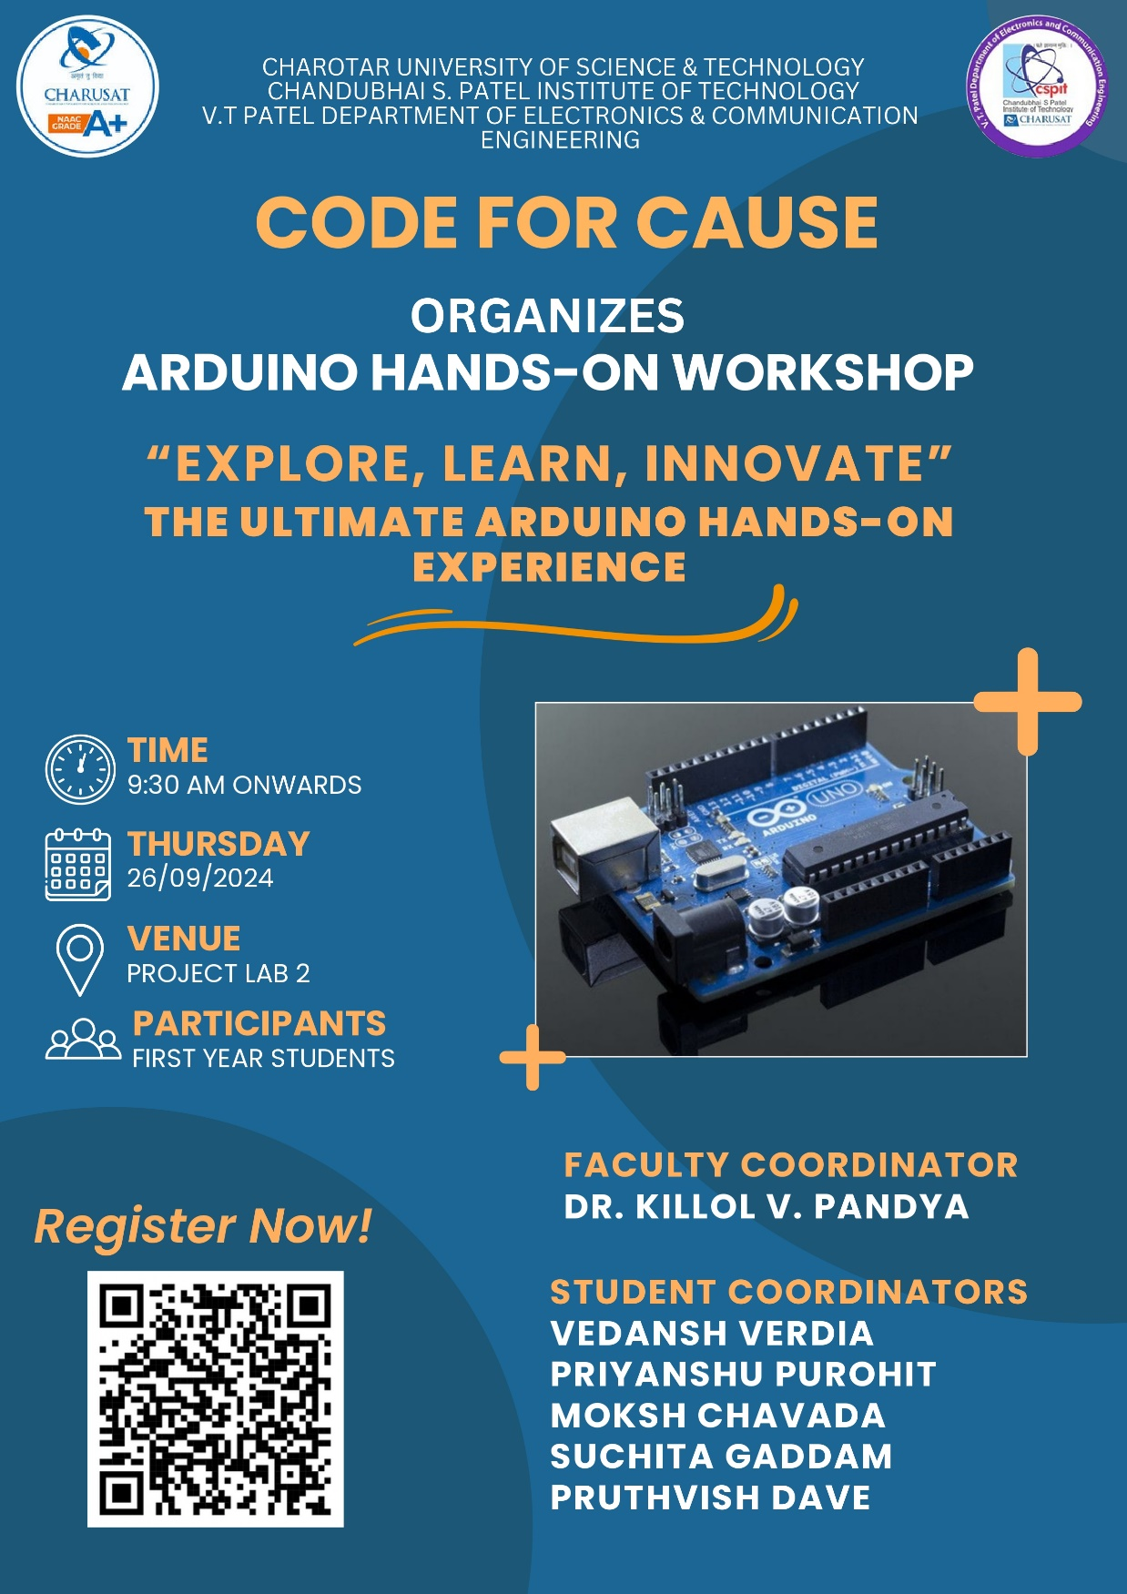

Event 2 Name: Arduino Workshop 2
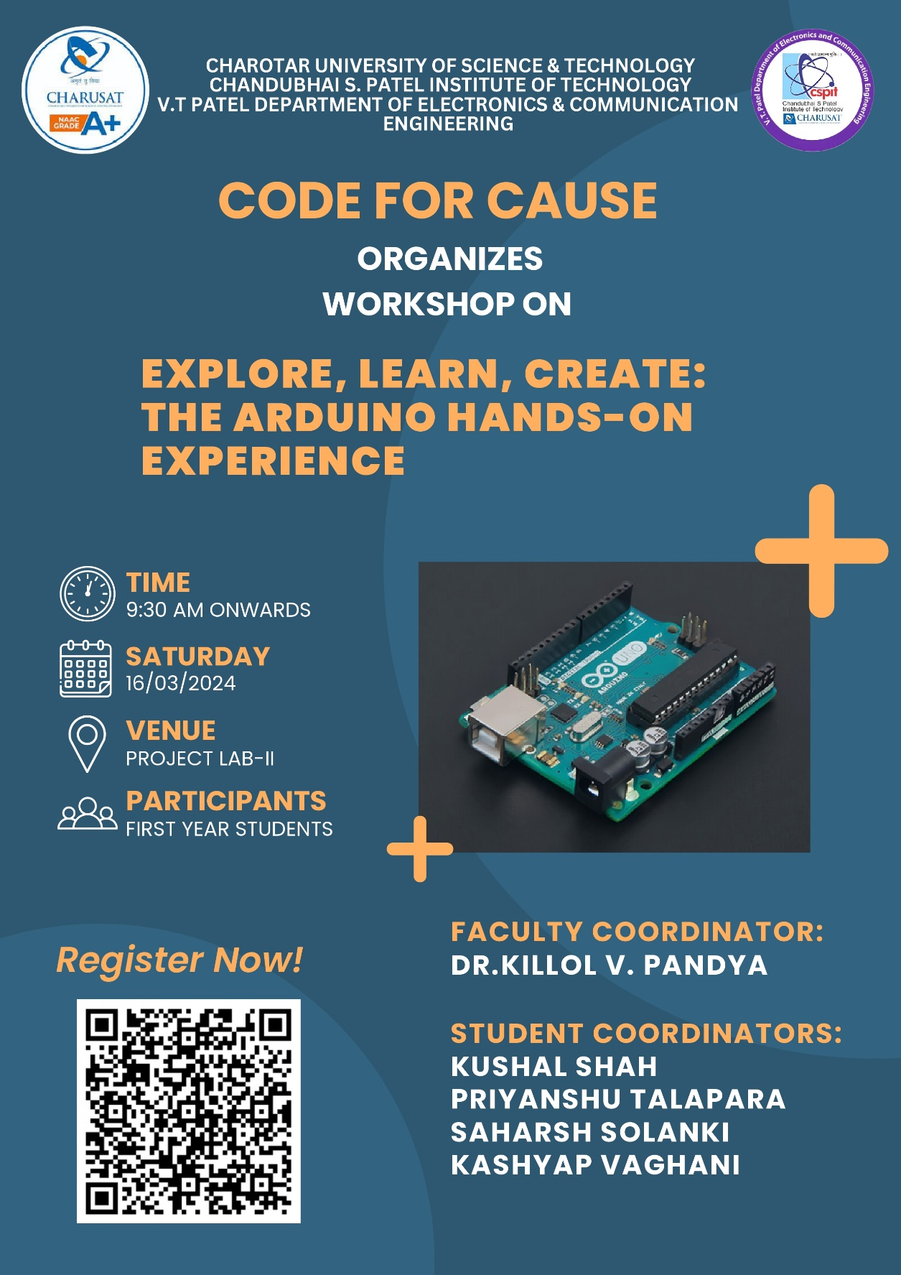

Event 3 Name: C Hackathon
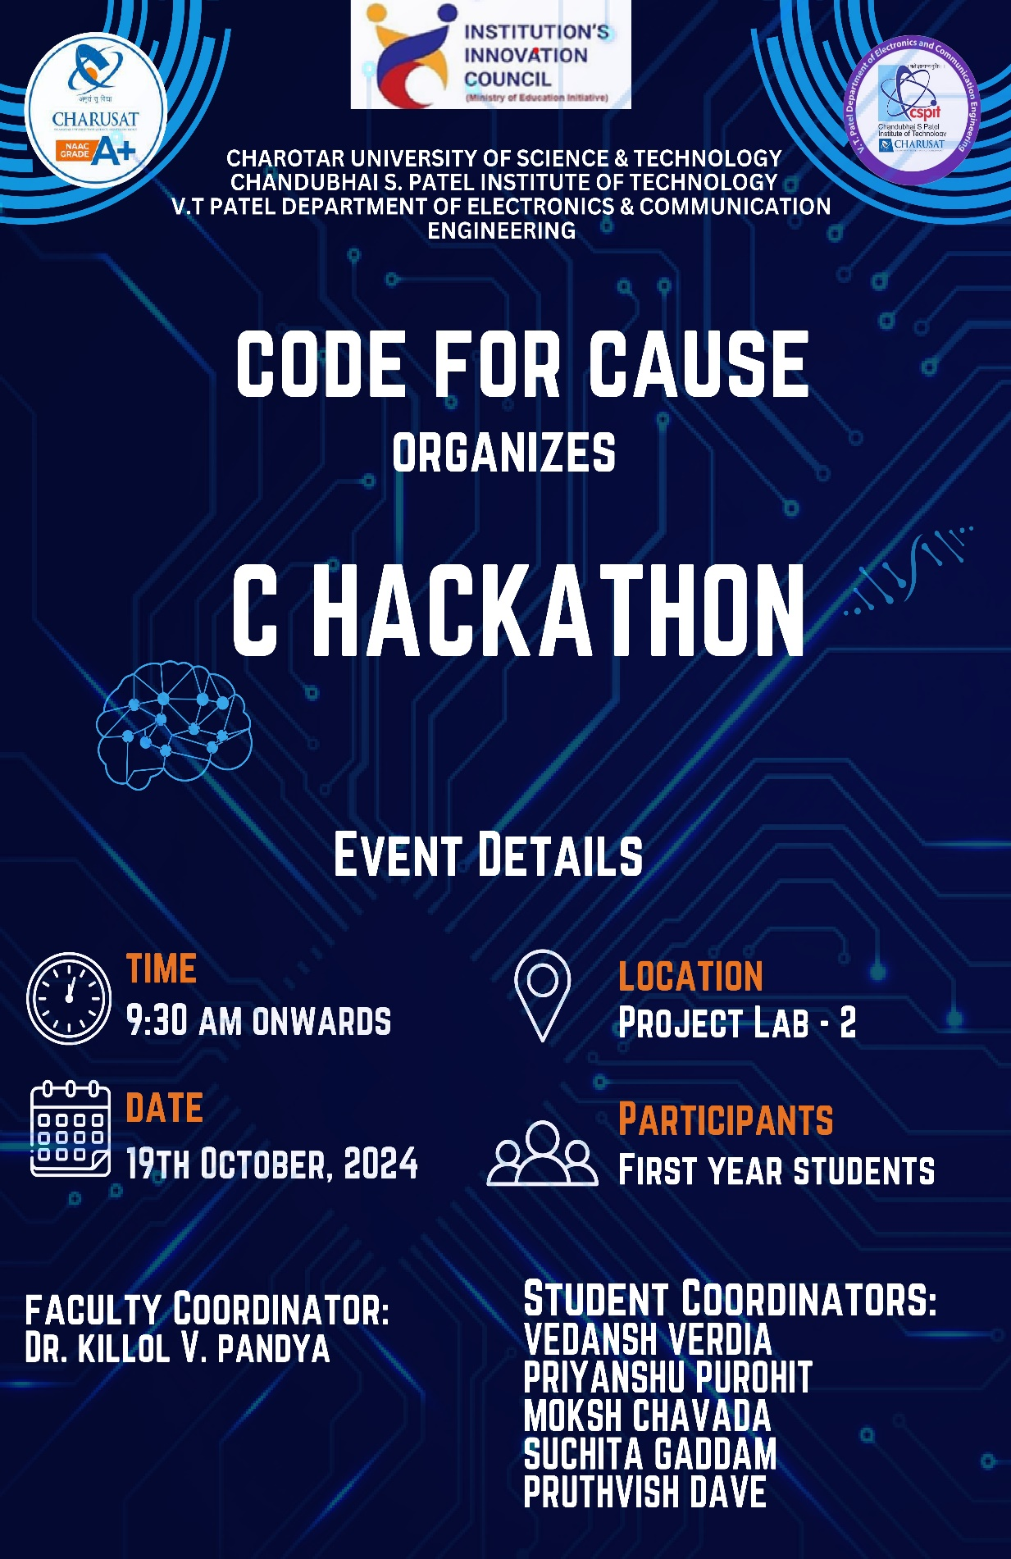
Event 4 Name: Code Fiesta

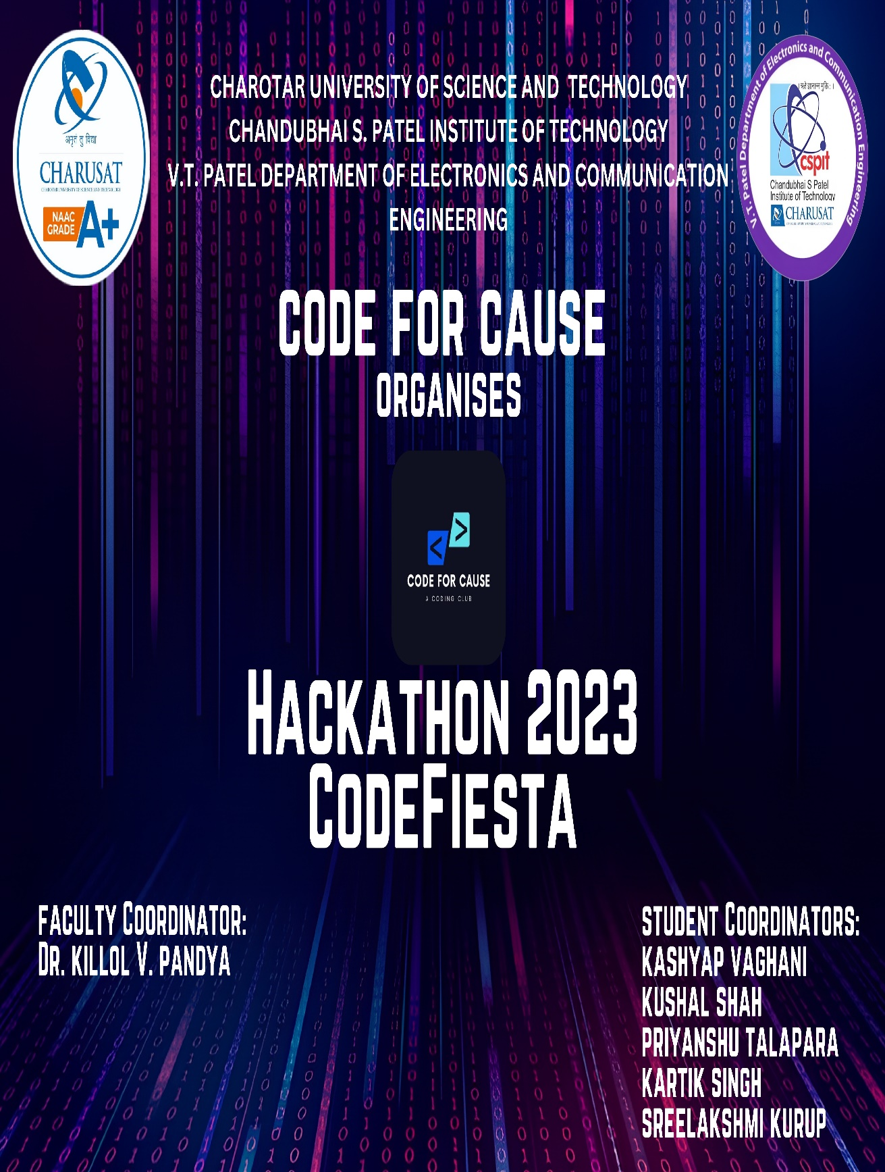

Event 5: CODE.PY-2.0
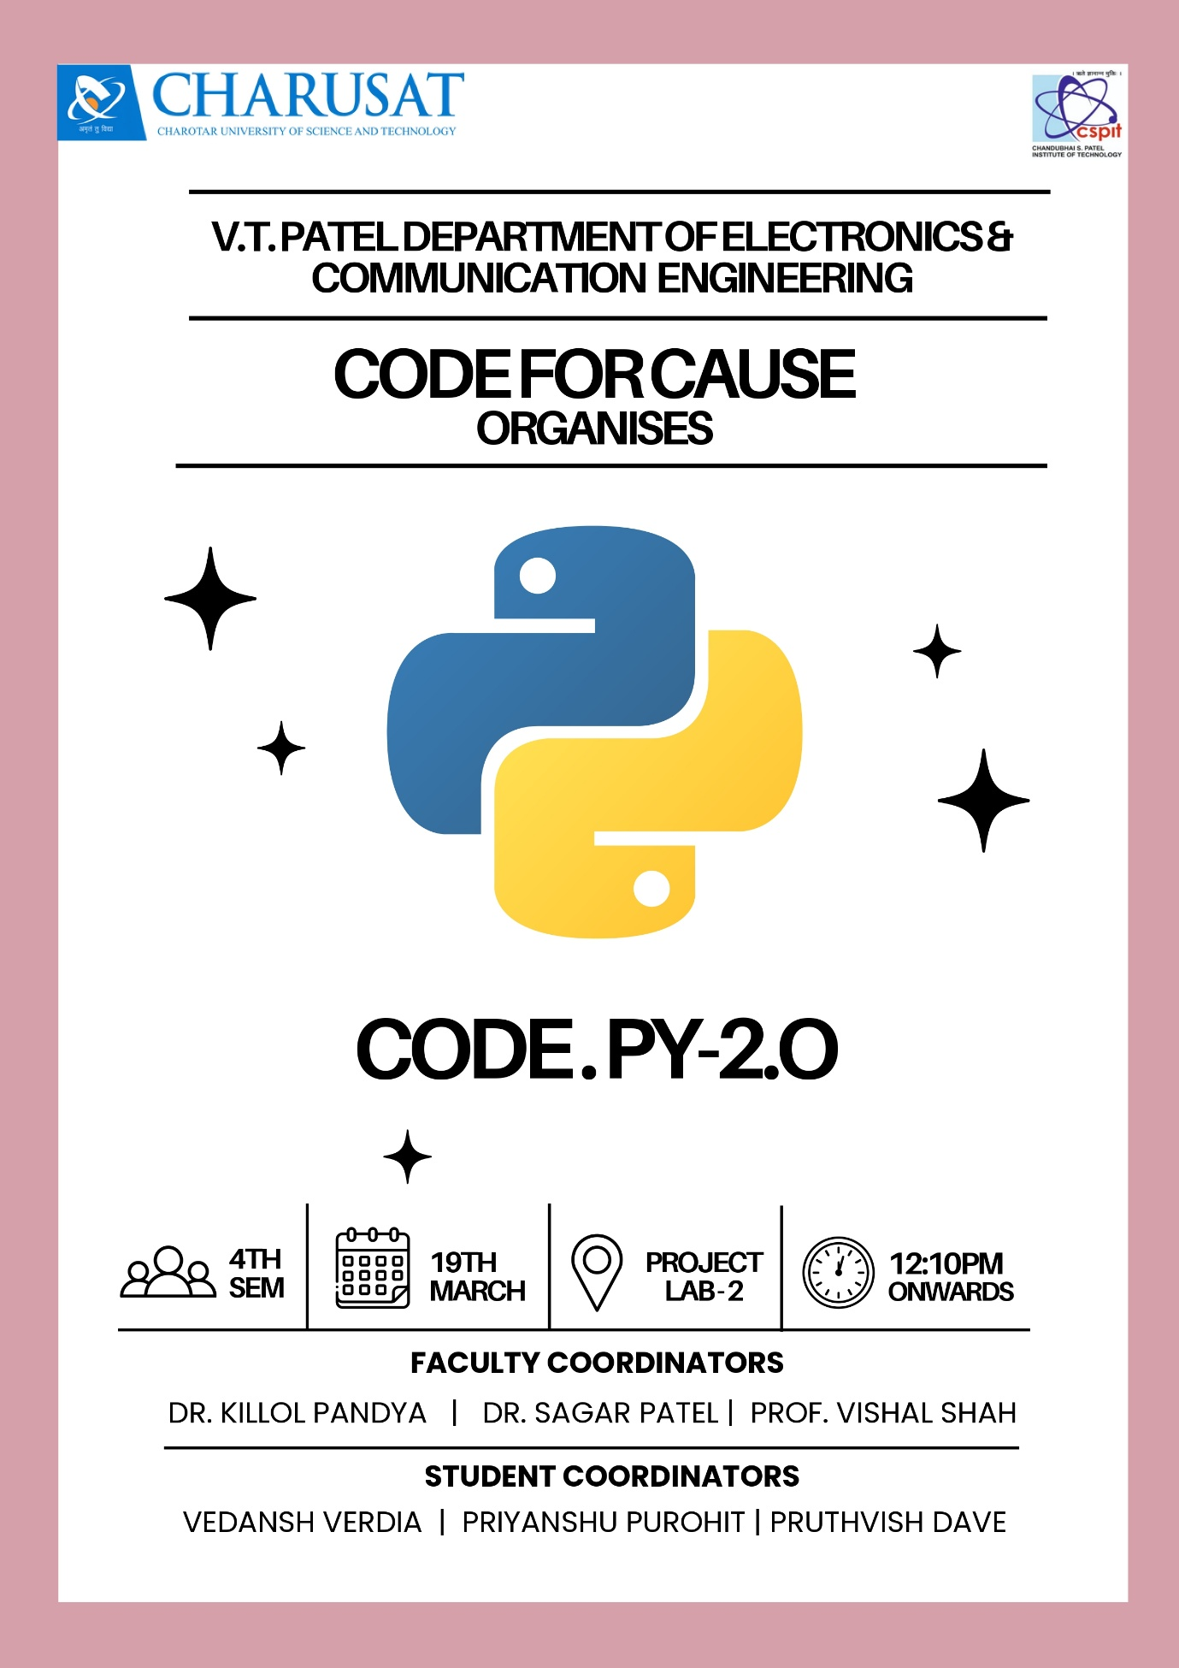
Event 6: C++ CODATHON
